«NARXOZ UNIVERSITY»
School of Digital Technologies

REPORT
on the Professional Internship
at
KnewIT Programming School,
Almaty, Kazakhstan

Student of the 4 year, 4-year program
Educational Program: Digital Engineering
Full Name of the Student: Azamat Zautbek
Contact Information:
Email: azamat.zautbek@narxoz.kz
Phone: +7 (___) ___-__-__
Internship Supervisor (from the University)
Full Name: _______________________
Email: _______________________
Internship Supervisor (from the Company)
Full Name: Nurbek Moldiyaruly Bekaulov
Email: nbekaulov@gmail.com

Almaty, 2026
1. Brief Description of the Company
My industrial internship took place at KnewIT, a programming school working in Kazakhstan. The school prepares IT developers both from the very beginning and at a continuing level, its courses last from one to seven months, and every course is built around practice and around a project that the student makes himself. The school is headed by Nurbek Moldiyaruly Bekaulov.
The teaching is organised in several directions. Backend development is represented by Python with Django, by Java, by Go and by PHP with Laravel; frontend development by JavaScript, React, Angular, Vue and HTML with CSS; mobile development by Android; the direction of data and artificial intelligence by SQL, Data Science, AI Engineering and Prompt Engineering. Besides these there are the courses of C and C++, C# and Software Engineering. A month of study costs approximately from forty to seventy five thousand tenge, and the more advanced directions are priced higher.
Everything in the school is built around one declared result: a graduate should leave with practical skills and be able to start working as a Junior or a Middle developer. For that reason the process is not limited to lectures. Each group is led by a teacher, follows a schedule, submits assignments and receives grades, and the progress of every student is followed from the first lesson to the last.
Running many groups at the same time creates an obvious need for a single system that holds all of this together, and that system is exactly what I worked on during the internship. It consists of the public site of the school and of three private areas - for the student, for the teacher and for the management. I was included in the development team as its full member and performed real production tasks rather than training exercises.
Initial Conversation with the Internship Supervisor
Our first conversation was devoted to how the school actually works: the way groups are gathered, the way a schedule is built, how attendance and grades are kept, and how the payment for the courses is controlled. My supervisor described what the teachers and the management were expecting from the future platform and which of their daily problems it was supposed to remove.
After that we agreed on my role and on the order of the work: the database and the server foundation first, then the cabinet of the student, then the cabinet of the teacher, then the analytics for the management, then the public site, and the tests and the deployment at the end. Separately he went through the internal regulations of the company and the requirements of labour safety, and drew my attention to the fact that the system stores the personal data of the students, so access rights and the protection of that data carry the same weight as the functions themselves.

2. Key Areas of Activity
The declared areas of activity of KnewIT are the teaching of IT development in the directions of backend, frontend, mobile development, data and artificial intelligence; the organisation of practice and of the students' own projects inside every course; the preparation of graduates for the position of a Junior or a Middle developer; and the development of the school's own digital tools for the teaching process.
My internship belonged to the last of these areas. The work followed the approved schedule plan and was divided into eight stages:

Description of Work | New Knowledge or Skills Acquired | Application of These Skills or Knowledge
Design of the database and of the server foundation | Building a relational schema, relations and constraints; work with FastAPI and SQLAlchemy | A schema of twelve tables holds the students, the groups, the lessons, the attendance, the grades, the assignments and the payments of the school
Login mechanism and access rights | Token authentication, safe storage of passwords and the verification of rights on the server side | Three roles coexist in one system, and a teacher cannot read or change the data of a foreign group even through a direct request
Development of the user interface | Assembling components with Next.js, React and TypeScript and linking them to the data of the server | Three cabinets and the public site are assembled from one shared set of blocks
Preparation and presentation of analytics | Aggregation of data, comparison of periods and the building of charts | The management sees the headline figures, the trends and the list of the students who need attention, and takes the report away as a file
Work with the files of the users | Receiving, storing and checking files sent from the browser | A student attaches the assignment as a file and the teacher opens it and grades it
Interface in two languages | Organisation of dictionaries and a safe return to the main language | The public site works in Russian and in Kazakh, and a missing translation cannot leave a blank space on the page
Automatic testing | Writing tests for the server and for the interface | One hundred and sixty four tests cover the API and the interface, and a broken version is stopped before the publication
Preparation for the deployment | Containers, a build in several stages and the configuration of the environment | The database, the API and the site start with one command and can be published on any server

3. Brief Description of the Company’s Issues/Challenges
The difficulties I met during the internship were connected less with unfamiliar technologies than with the behaviour of the system over time and under load.
1. A demonstration that goes stale. The platform had to be shown to the teachers and to the management long before real students appeared in it. Data written with fixed calendar dates loses its meaning within a month: the current week turns out empty, the attendance exists only in the past, and the demonstration looks dead. The second half of the problem was that generated data must remain logical - a grade cannot appear before its lesson, and a finished group cannot have lessons ahead of it. What I did was describe every group not by dates but by the distance in days from the current day, giving the finished groups negative values. Since then the generated school stays alive on any date and never contradicts itself.
2. A late answer overwriting a fresh one. On the screens of the management the filters by period and by course are switched quickly, and each switch sends a new request. From time to time a slower earlier request returned after the newer one and put outdated numbers on the screen, so the person was looking at the figures of a filter he had already left. I closed this by giving every request its own number inside the common loading mechanism: an answer is accepted only while its number remains the last one, and anything that arrives late is discarded.
3. An analytical screen that was too heavy. The page of the management needs the headline figures, twelve months of trends, the distribution of the grades, a comparison of the courses and of the teachers, and the list of the students at risk. My first version asked the database separately about every course, every teacher and every student, so a single page produced dozens of queries and opened slowly. I rebuilt it so that the attendance, the grades and the enrolments are read by three queries, and all the indicators, including the comparison with the previous period, are counted over those rows inside the application.
None of these problems had a ready answer in the documentation. I reached the solutions by reading the sources of the libraries, trying several variants on the generated data and discussing the results with my supervisor.

4. Practical Experience Gained and Recommendations for Further Cooperation with the Company

The internship gave me practical experience of full-stack development. Among the professional skills I acquired are: development of the server side (FastAPI, SQLAlchemy, design of REST APIs); development of the client side (Next.js, React, TypeScript, Tailwind CSS); design of a database - a working schema with relations and constraints rather than a diagram on paper; the foundations of information security, namely token authentication, hashing of passwords, roles and the verification of rights on the server; preparation and presentation of analytical data; work with files sent by users; building an interface in two languages; writing automatic tests for both sides of the system; describing a project in containers; and, finally, the working habits of a team - planning, agreeing a result with a supervisor and leaving documentation after oneself.
What I value most is that the system was written for people who will use it every day, not for a mark in a journal. A technically correct answer turned out to be only half of the task: the same screen has to be convenient for a teacher who fills it in after every lesson, and it has to be safe for the personal data of the students. Another lesson I will keep is that a restriction shown only in the interface is not a restriction at all, because the interface can always be walked around - it must stand on the server.
The aim of the internship was, in my opinion, reached in full. Everything listed in the schedule plan was completed within the agreed dates, and the result is a finished working platform of the school - a public site and three cabinets, covered with tests and prepared for publication.
Working with an intern at KnewIT is arranged well: the tasks given are real, the supervisor stays available throughout, and the result of the intern goes into the actual process of the school rather than into a folder. I would recommend keeping this cooperation and offering the students of the following years the same opportunity to take part in a production project. Such work converts what is learned at the university into a professional skill faster than any other form of practice.

Appendix. Screenshots of the Developed System
The screenshots below are taken from the working system. The names, the groups and the figures shown on them belong to the generated demonstration data and do not correspond to real students of the school.
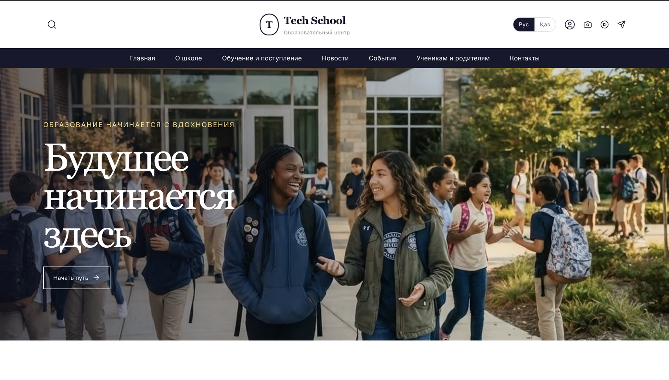
Figure 1 – The main page of the school website
The opening screen of the public site. The top bar carries the search, the switch between the Russian and the Kazakh languages and the entrance to the private cabinet; under the menu runs the video of the main screen, which is assembled from the photographs of the school by one of the media scripts written during the internship.
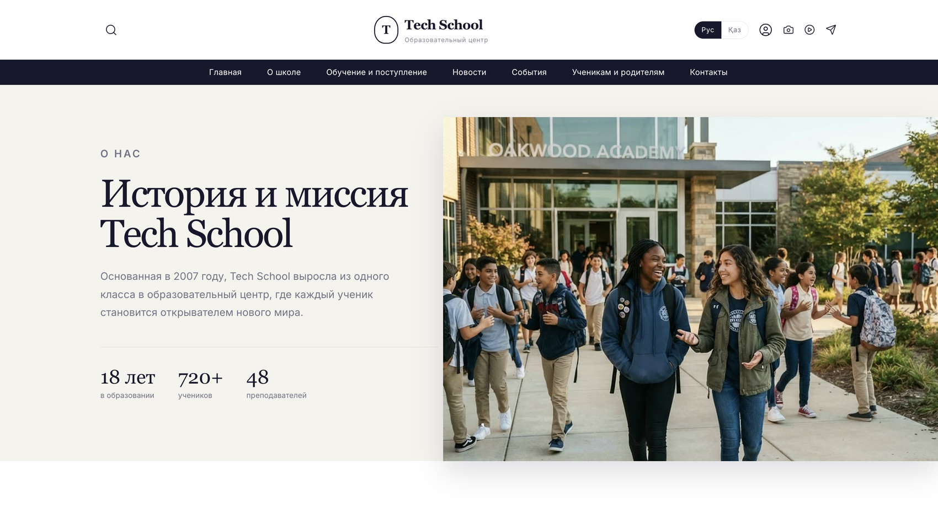
Figure 2 – The page «About the school»
The history and the mission of the school. Under the text stand the summary figures - the years of work, the number of students and the number of teachers - and further down the page the history is continued as a timeline of the key events.
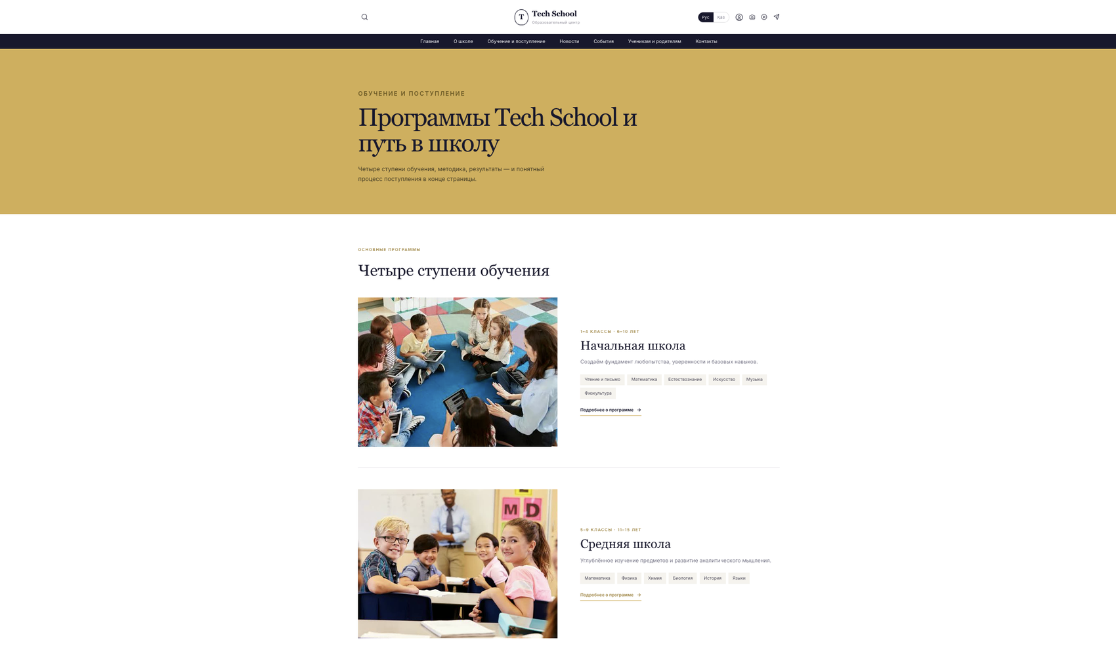
Figure 3 – The page «Studies and admission»
The programmes of the school. Every step of study is shown with the age of its students, a short description and the list of the subjects, and opens into a page of its own; the process of admission is described at the bottom of the same page.
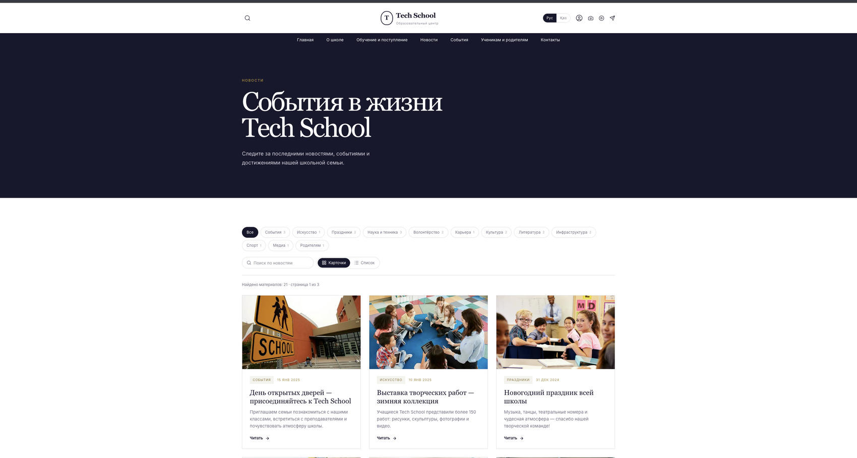
Figure 4 – The news section
The materials can be narrowed by a category, searched by words and shown either as cards or as a list; they are divided into pages of nine. The line under the filters reports how many materials were found and which page is open, and every material has a page of its own.
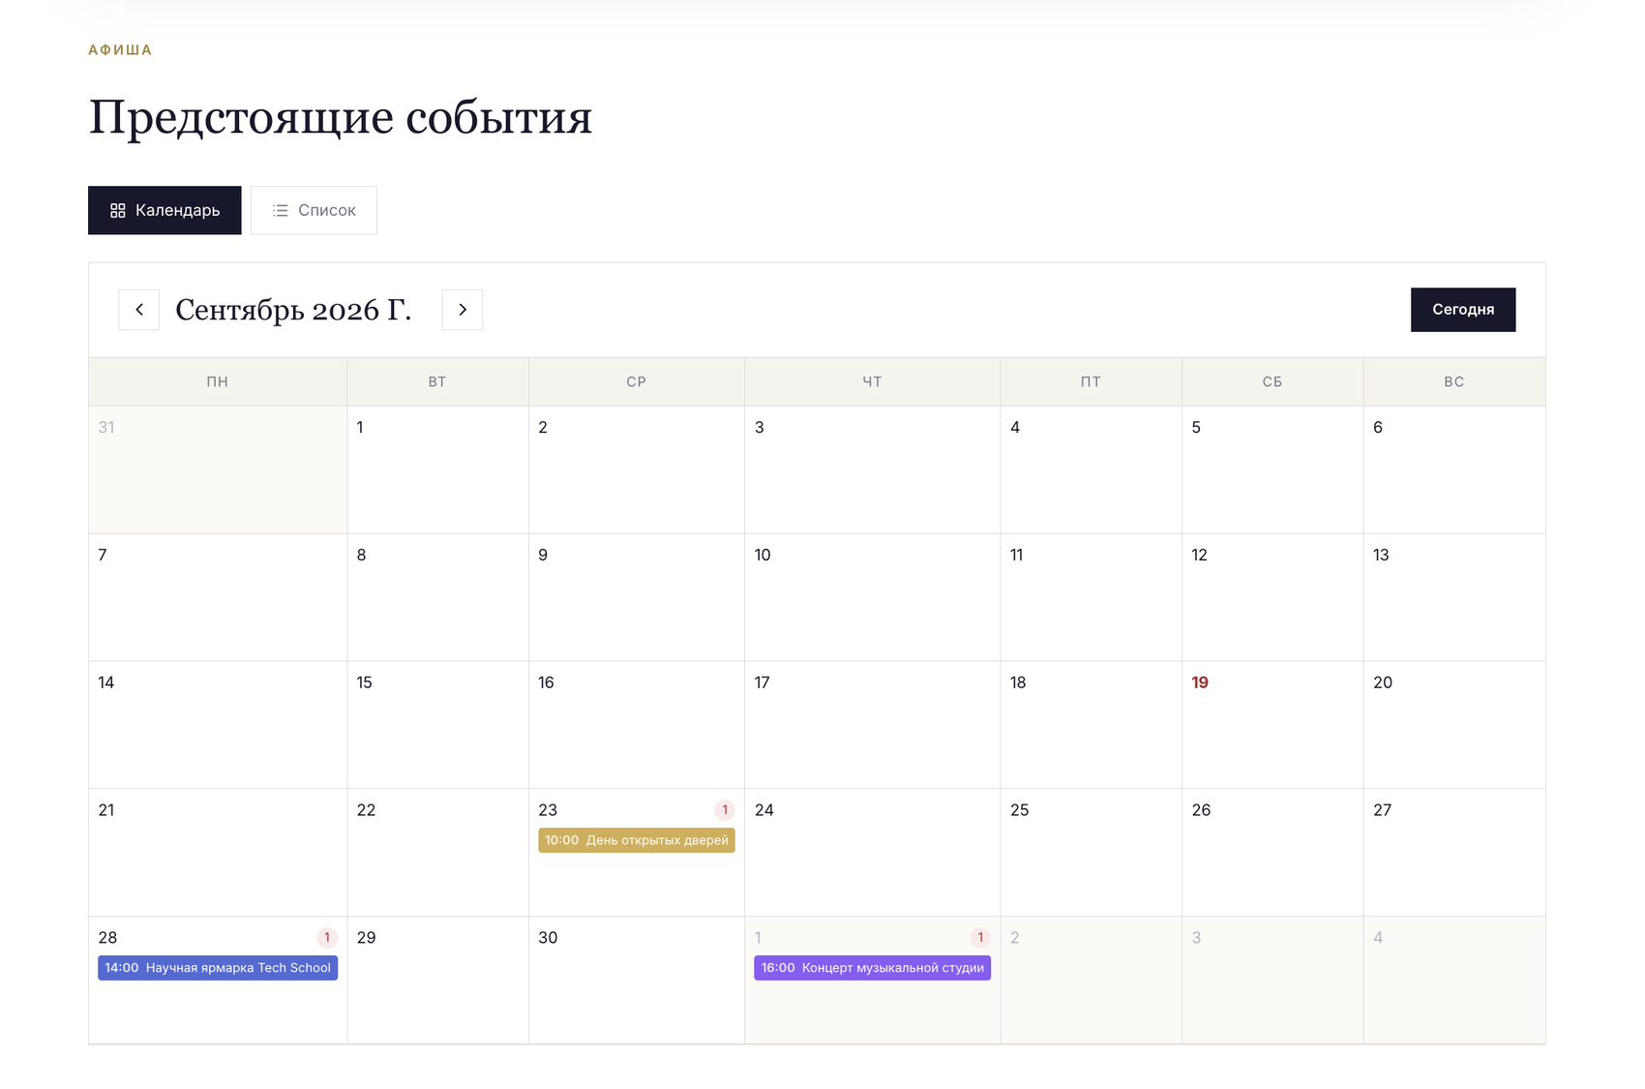
Figure 5 – The calendar of the events
The month is built in the browser without an external calendar library: the grid always begins on Monday, the current day is highlighted, and an event is placed on its own date with the time and the title. A click on a day opens the card of the event with the button for signing up, and the same events can be shown as a simple list.
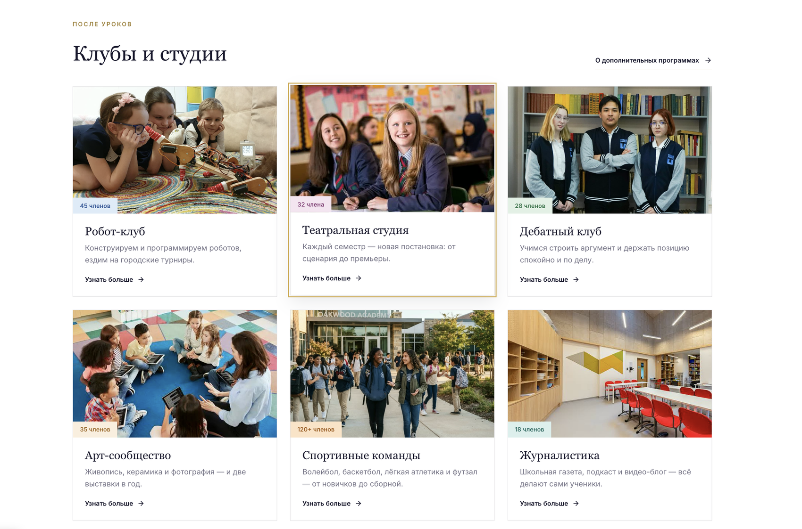
Figure 6 – The clubs and studios of the school
Every card shows the number of members and leads to a separate page of the club with its description, its schedule and the form of application.
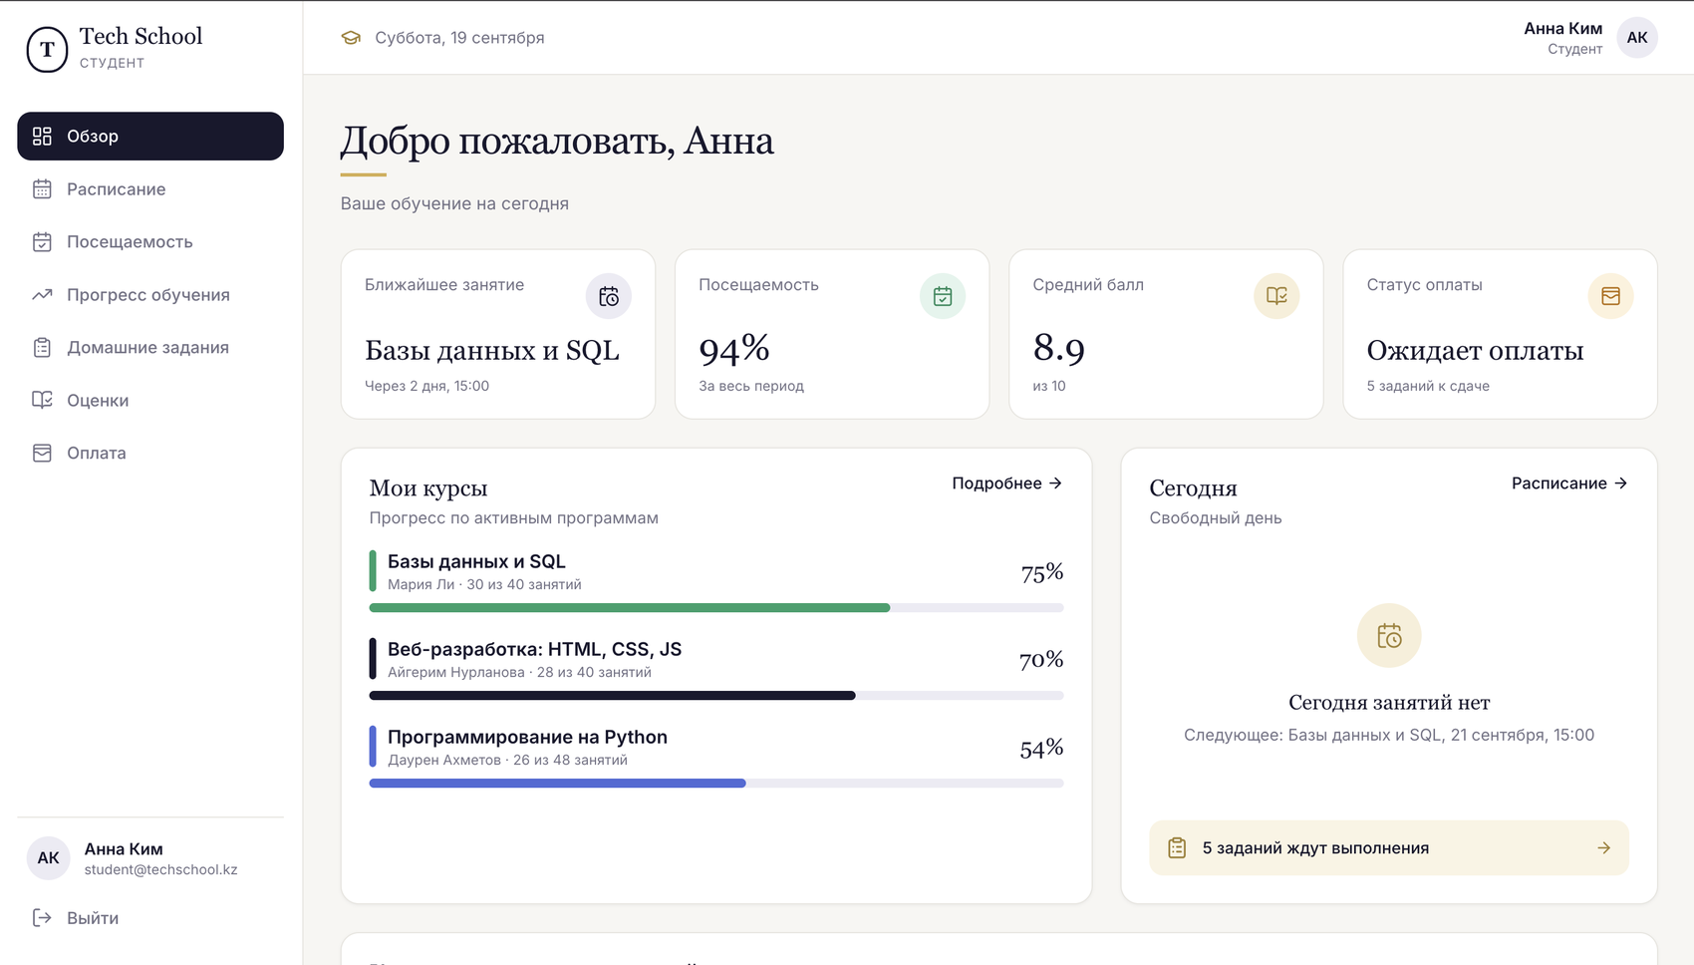
Figure 7 – The student cabinet, the section «Overview»
The four tiles at the top show the nearest lesson, the attendance for the whole period, the average grade on the ten-point scale and the state of the payment. Under them the progress of every active course is drawn as a bar with the teacher and the number of lessons already passed, and on the right stands the plan of the current day together with the number of the assignments waiting to be done.
The left menu leads to the remaining sections of the cabinet. «Schedule» shows the lessons as a week or as a month with the teacher, the topic and either the room or the mark that the lesson is online. «Attendance» gives the general percentage as a ring and eighteen weeks as a map of coloured squares, where the colour of a day is the worst of its statuses and the tooltip names the course. «Progress» opens every course with its full plan of lessons and the share of it that is already behind. «Homework» lists the assignments with their deadlines and allows an answer to be sent as a text and as an attached file of up to ten megabytes. «Grades» is a journal of the subjects against the dates together with the movement of the average mark. «Payment» shows the invoices, the history of the payments and their statuses.
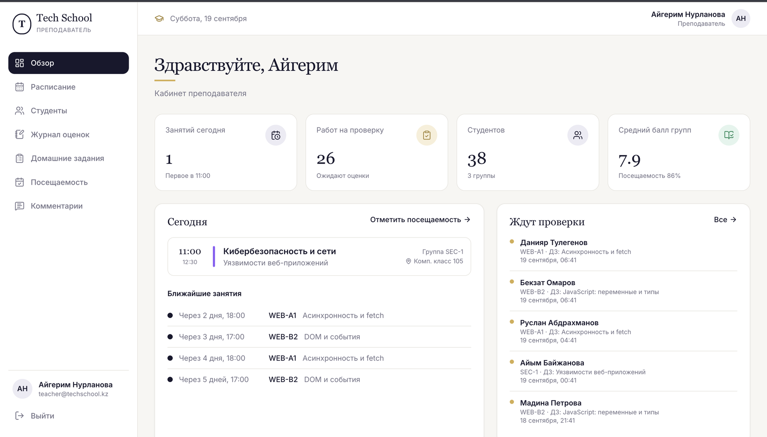
Figure 8 – The teacher cabinet, the section «Overview»
The tiles show the lessons of the current day, the number of works waiting to be checked, the number of students in all the groups of the teacher and their average grade together with the attendance. Below on the left stand the timetable of the day and the nearest lessons, and on the right the queue of the submitted works with the student, the group, the assignment and the time of sending.
The other sections are reached from the left menu. «Schedule» repeats the timetable for a week or a month. «Students» is the list of all the students of the teacher with a filter by group, where every name opens a profile with the attendance, the grades, the submitted works and the earlier remarks. «Gradebook» is a grid of the students against the lessons in which a click on a cell puts, changes or removes a grade. «Homework» allows a task to be created for a group and the submitted works to be checked with a grade and a comment. «Attendance» is the sheet where present, late, absent or excused is marked for a chosen lesson and saved by one request. «Comments» keeps the remarks to a student - praise, a note or a recommendation - which the student then sees in his own cabinet.
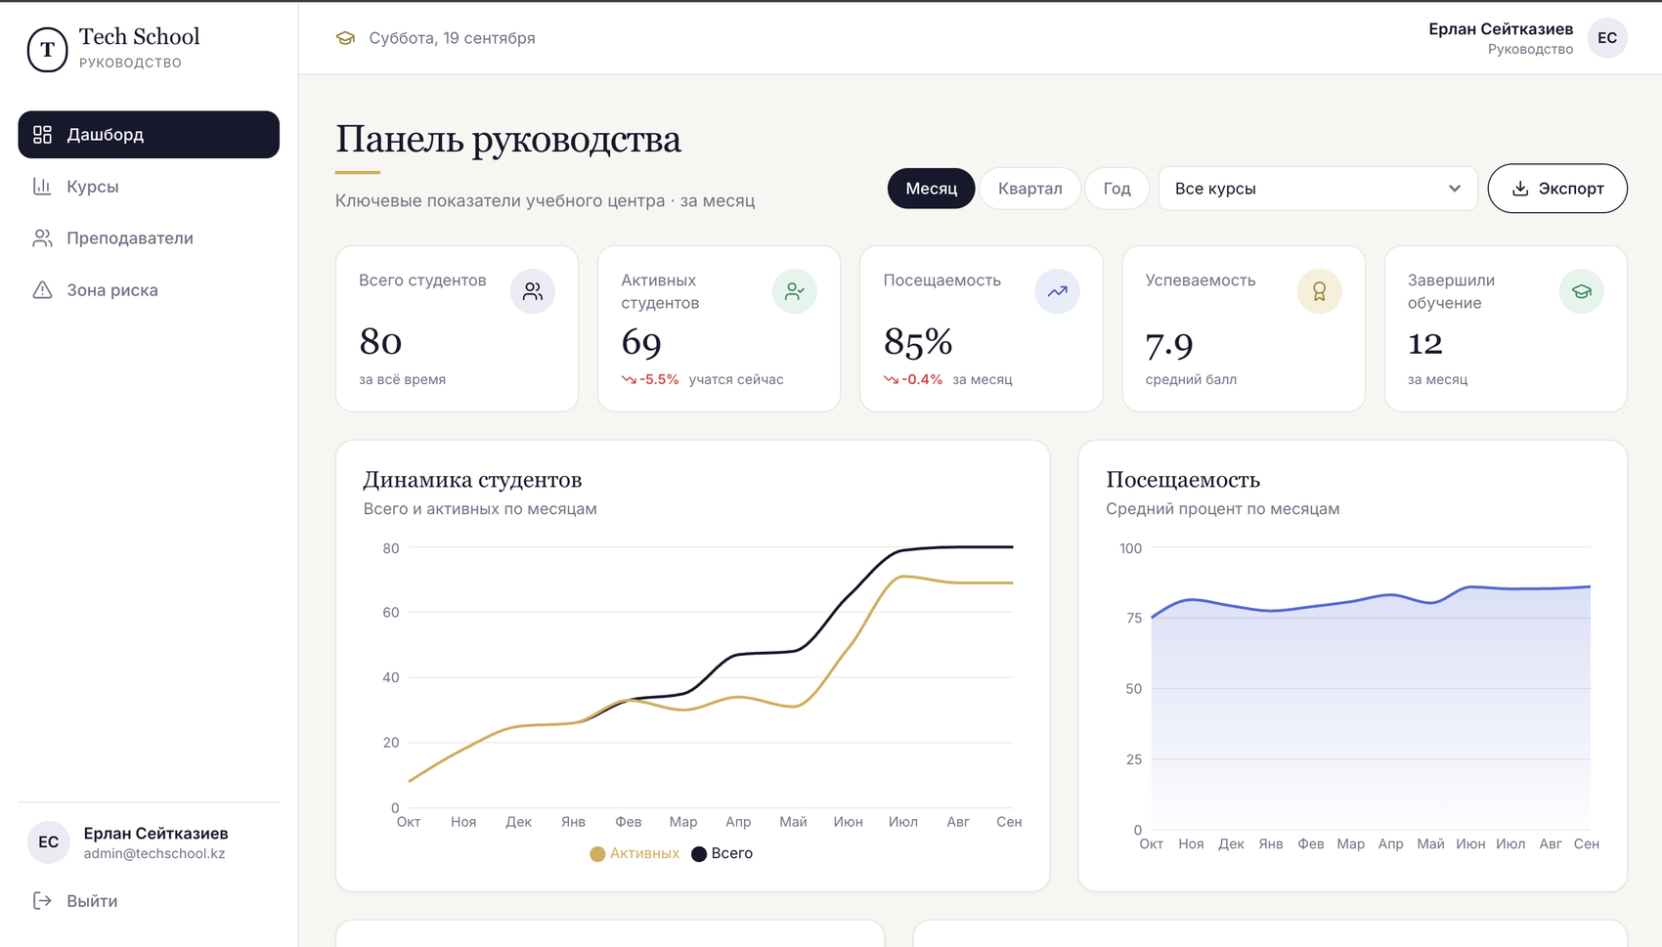
Figure 9 – The cabinet of the management, the dashboard
Above the figures stand the filter by period, the filter by course and the button that takes the report away as a file. The five tiles show the total and the active students, the attendance, the average grade and the number of those who finished; under a value stands its change in percent against the previous period of the same length, which is why a fall is immediately visible. Below them are the charts of the number of students and of the attendance for the last twelve months.
The left menu holds three more pages. «Courses» compares the programmes - how many students were enrolled in each of them, how many study now, how many finished and what share of a group reaches the end. «Teachers» shows the load and the results of every teacher: the number of groups, the number of students, the average grade and the attendance. «Risk zone» collects the students who need attention - those whose attendance is under seventy five percent, whose average grade is below seven, or who have an unpaid invoice - and names the reasons next to every student, placing the most difficult cases on top.
Signature

